Aim: To study different network simulators used for Wireless Sensor Networks and Internet of Things.

Requirements:
- Computer / Laptop
- Internet Connection
- Web Browser
- Tinkercad
- Cooja
- CupCarbon

Theory:
A Network Simulator is a software tool used to simulate the behavior of computer networks without using actual hardware devices.
In Wireless Sensor Networks (WSN) and IoT systems, simulators help researchers and developers test network protocols, communication, and device performance before implementing them in real environments.

Common Network Simulators

- Circuit Simulation using Tinkercad
Tinkercad is an online electronics simulation platform developed by Autodesk. It allows users to design, build, and simulate electronic circuits without using physical hardware.
In Tinkercad Circuits, users can work with components such as microcontrollers, sensors, LEDs, resistors, and breadboards. It also supports programming of microcontrollers like Arduino using C/C++ code. The simulator provides real-time visualization of circuit behavior and helps students test and debug their programs.
Tinkercad is widely used in education because it provides a simple interface for beginners to understand electronics, embedded systems, and microcontroller programming without the need for physical components.

- Network Simulation using Cooja
Cooja is a network simulator used to simulate wireless sensor networks (WSN). It is part of the Contiki OS, which is an open-source operating system designed for Internet of Things (IoT) devices.
Cooja allows users to simulate networks of sensor nodes called motes. Each mote runs a Contiki program, enabling developers to test network protocols, communication mechanisms, and sensor applications. The simulator can emulate real hardware platforms such as Sky motes.

- IoT Network Simulation using CupCarbon

CupCarbon is a simulation tool designed for modeling and testing Wireless Sensor Networks and Internet of Things applications. It enables users to create sensor nodes, place them on a geographic map, and simulate communication between them.
CupCarbon integrates with geographic data such as maps to provide realistic environments for simulation. Users can configure node properties such as communication range, energy consumption, and data transmission parameters.
The simulator allows monitoring of network performance, packet transmission, and node interactions. It is widely used in research and education for designing IoT systems such as smart cities, environmental monitoring networks, and industrial sensor systems.

Procedure:
- Using Tinkercad
- Open a web browser and go to Tinkercad website.
- Sign in using Google account.
- Click Circuits → Create New Circuit.
- Add components like Arduino, LED, resistor and wires.
- Connect Arduino pin to LED through resistor.
- Write Arduino program..
- Start the simulation and observe the output.

- LCD
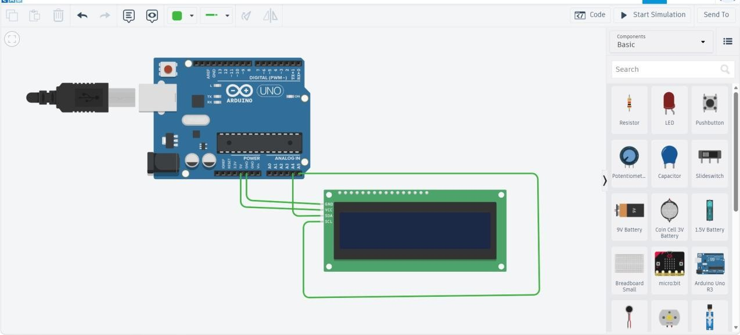

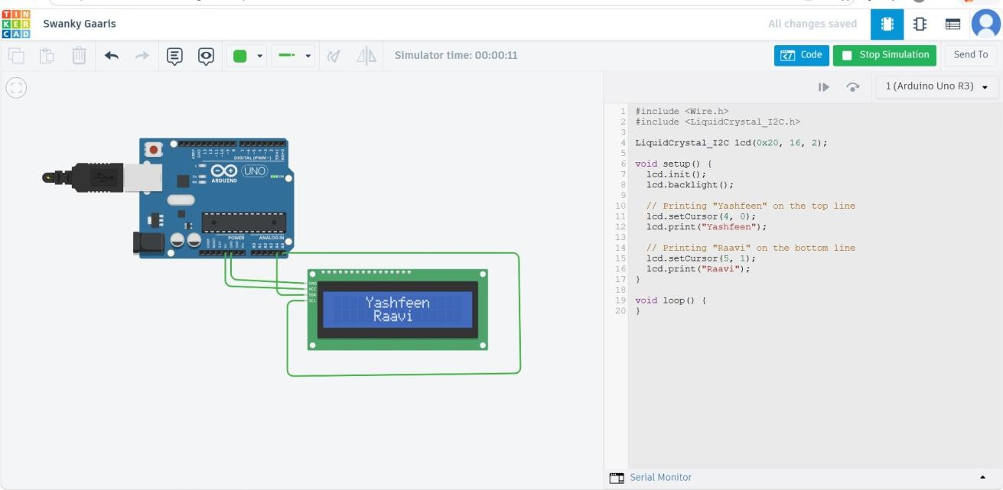
CODE :
#include <Wire.h> #include

<LiquidCrystal_I2C.h> LiquidCrystal_I2C lcd(0x20, 16, 2);
void setup() { lcd.init(); lcd.backlight()
;

// Printing "Priya" on the top line lcd.setCursor(4, 0); lcd.print("Yashfeen");

// Printing "Shah" on the bottom line lcd.setCursor(5, 1); lcd.print("Shah");
}

void loop() {
}

- Ultrasonic sensor
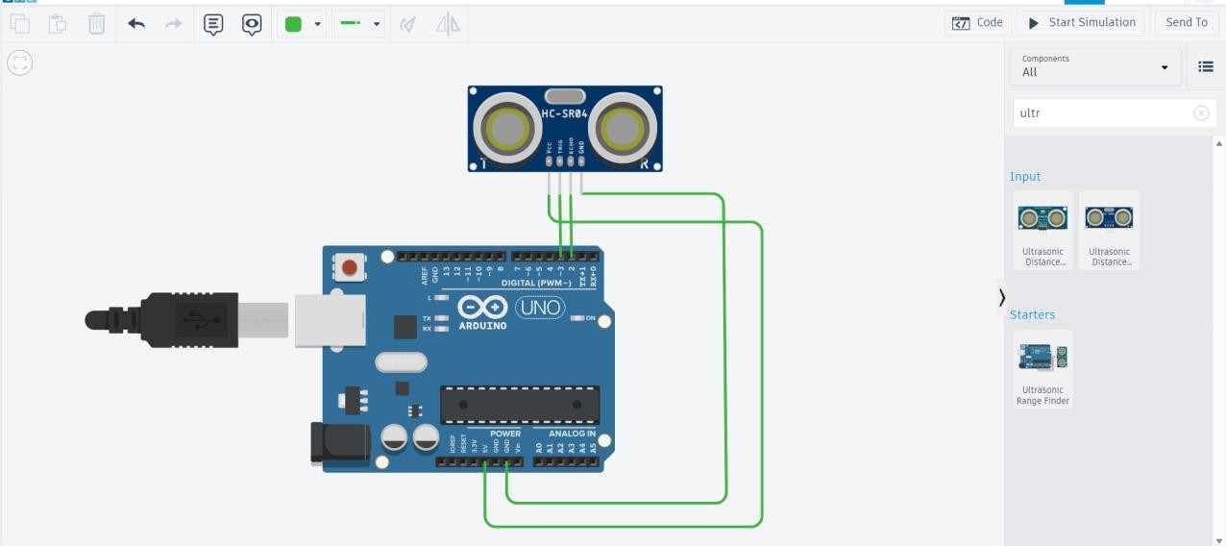
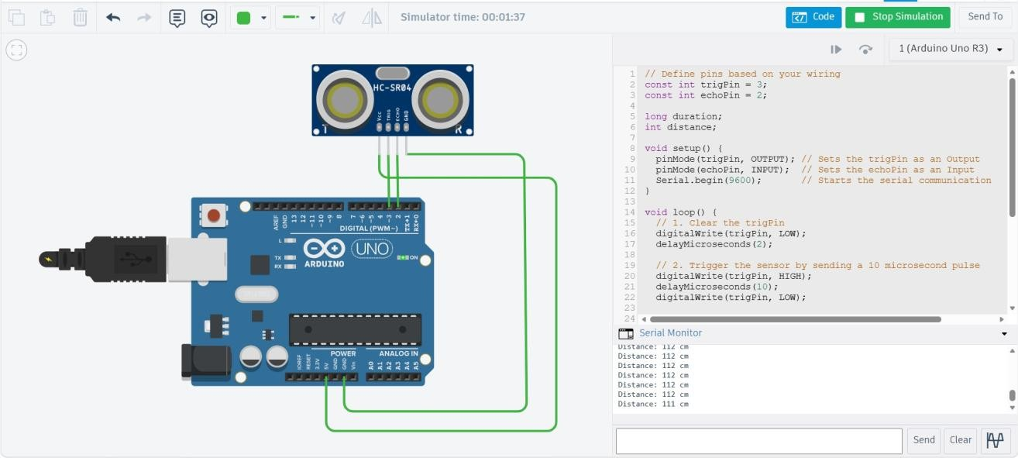

// Define pins based on your wiring const int trigPin = 3;
const int echoPin = 2;

long duration; int distance;

void setup() {
pinMode(trigPin, OUTPUT); // Sets the trigPin as an Output pinMode(echoPin, INPUT); // Sets the echoPin as an Input Serial.begin(9600); // Starts the serial communication
}

void loop() {// 1. Clear the trigPin digitalWrite(trigPin, LOW); delayMicroseconds(2);

// 2. Trigger the sensor by sending a 10 microsecond pulse digitalWrite(trigPin, HIGH); delayMicroseconds(1
0);
digitalWrite(trigPi n, LOW);

// 3. Read the echoPin (returns the sound wave travel time in microseconds) duration = pulseIn(echoPin, HIGH);

// 4. Calculating the distance
// Speed of sound is 0.034 cm/us. We divide by 2 (there and back). distance = duration * 0.034 / 2;

// 5. Print the distance to the Serial Monitor Serial.print("Distance: "); Serial.print(distance); Serial.println(" cm");

delay(200); // Wait a bit before the next reading
}

  - Using Cooja : Procedure

Step 1: Start the Virtual Machine
- Install and open Oracle VM VirtualBox.
- Load the Instant Contiki image.( InstantContiki can be installed from this Installation - Contiki web page)
- Start the virtual machine and login to the Linux system.

Step 2: Launch the Simulator
Open the terminal and run: cd contiki/tools/cooja , ant run This command launches the Cooja.
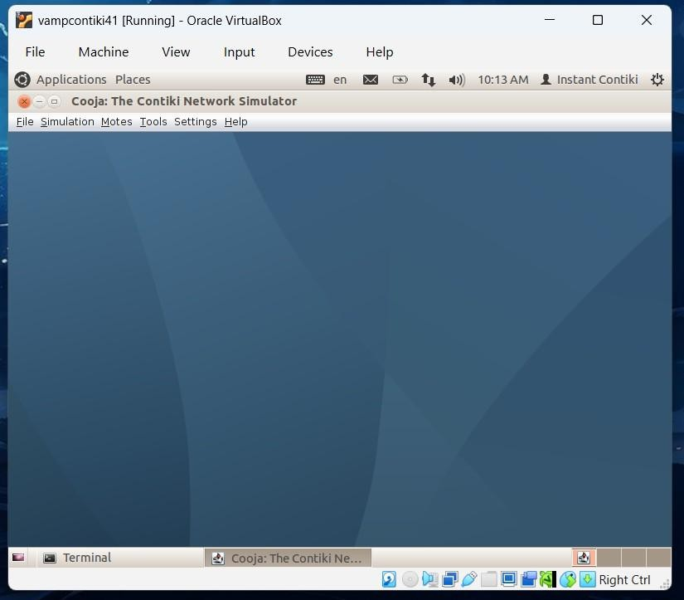

Step 3: Create a New Simulation
- Click File → New Simulation.
- Enter simulation name.
- Click Create.

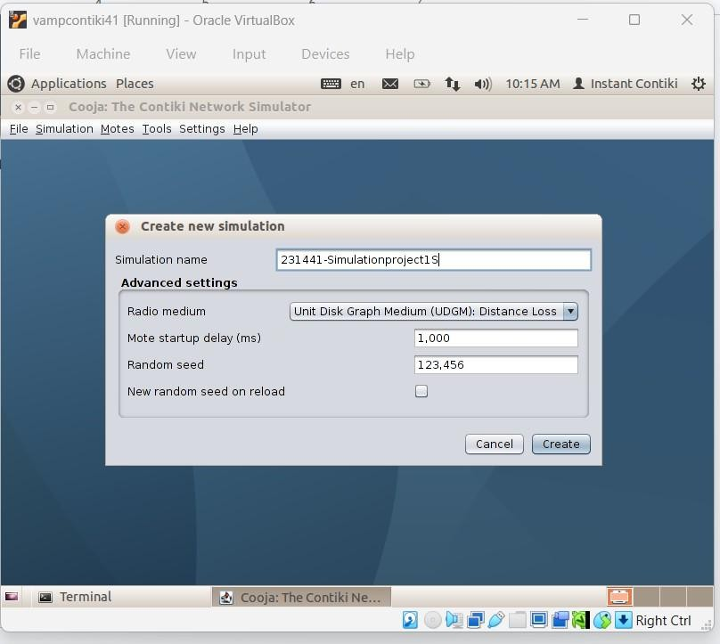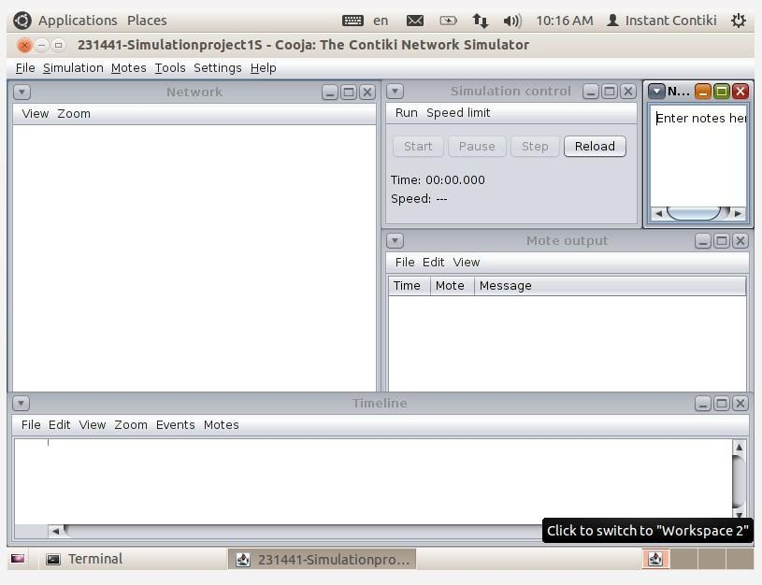

Step 4: Add Sensor Nodes (Motes)

- Click Motes → Add Motes.
- Select Sky Mote.
- Click Create New.
- Select the program: examples/hello-world/hello-world.c
- Click Compile.
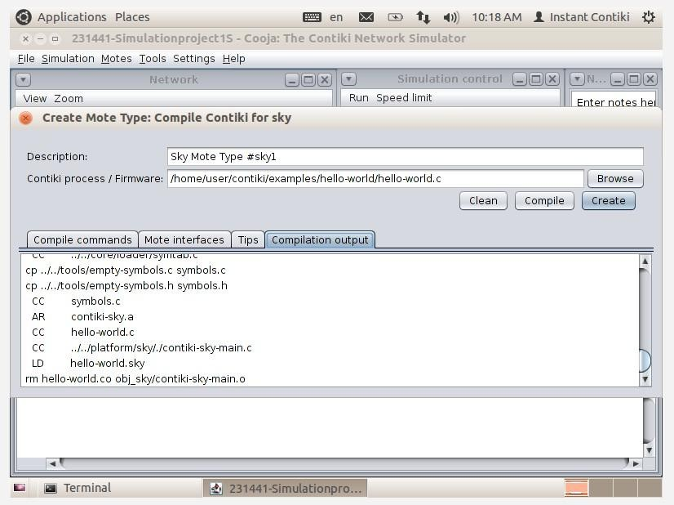

Step 5: Add Multiple Nodes
- Select Add motes to simulation.
- Enter number of motes: 5
- Click Add motes.

Five sensor nodes will appear in the simulation window.

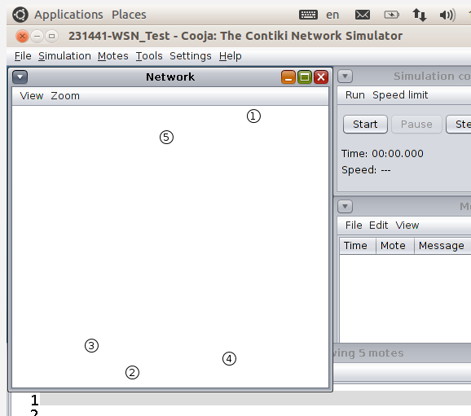

Step 6: Run the Simulation
- Click Start Simulation.
- Open Tools → Mote Output.

The output will display messages such as:

Hello, world Hello, world Hello, world
This indicates that the sensor nodes are running successfully.

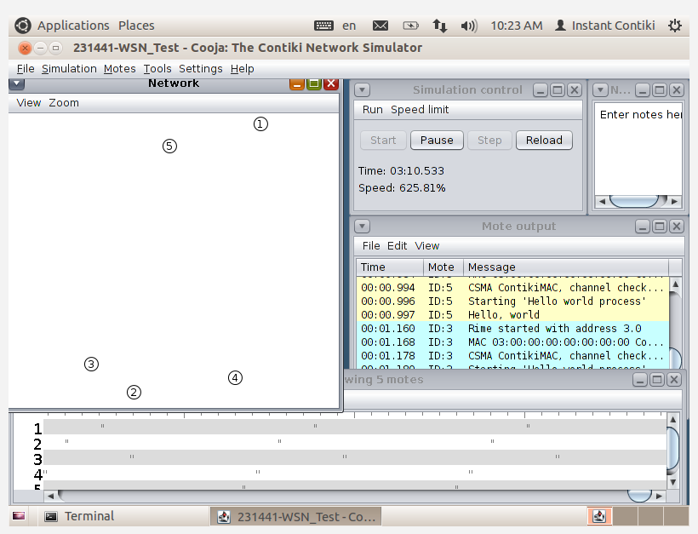

Step 7: Observe Network Activity
The following tools can be used to observe network behavior:

  - Tools → Radio Messages
  - Tools → Network
  - Tools → Timeline

These tools display:

  - wireless communication between nodes
  - packet transmission
  - node activity over time

Using CupCarbon - Procedure

Step 1: Download CupCarbon
- Open a web browser.
- Search for CupCarbon simulator download. Download CupCarbon Klines
- Download the latest version of CupCarbon from its official website.
- Open the extracted CupCarbon folder.
- Locate the file named: CupCarbon.exe
- Double-click the file to launch the simulator. The CupCarbon workspace window will appear with a map interface and toolbar.
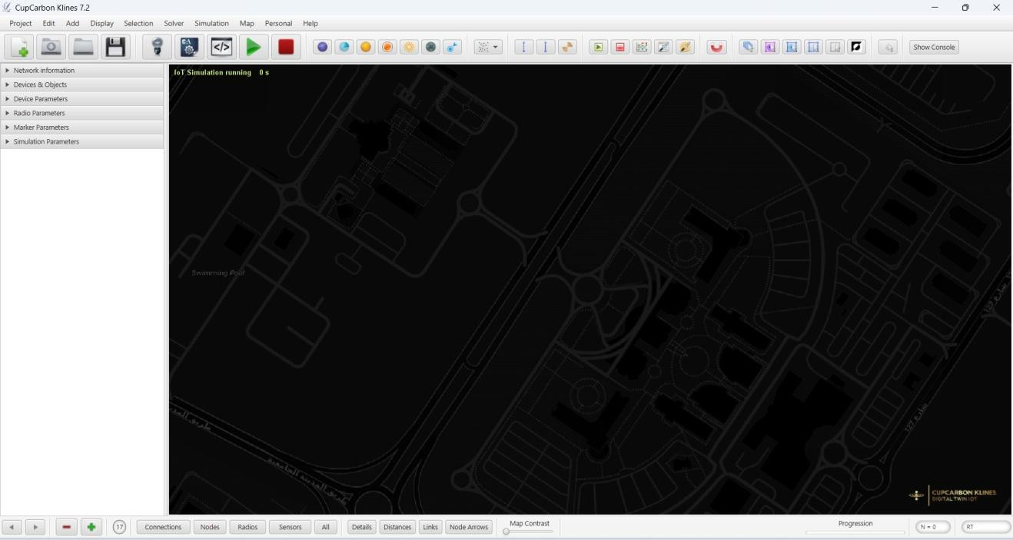

Step2 : Adding Sensor Nodes

Select Sensor Node Tool Place Nodes on the Map
- Click anywhere on the map to place a sensor node.
- Repeat the process to add multiple nodes.
The nodes will appear as small icons on the simulation map.

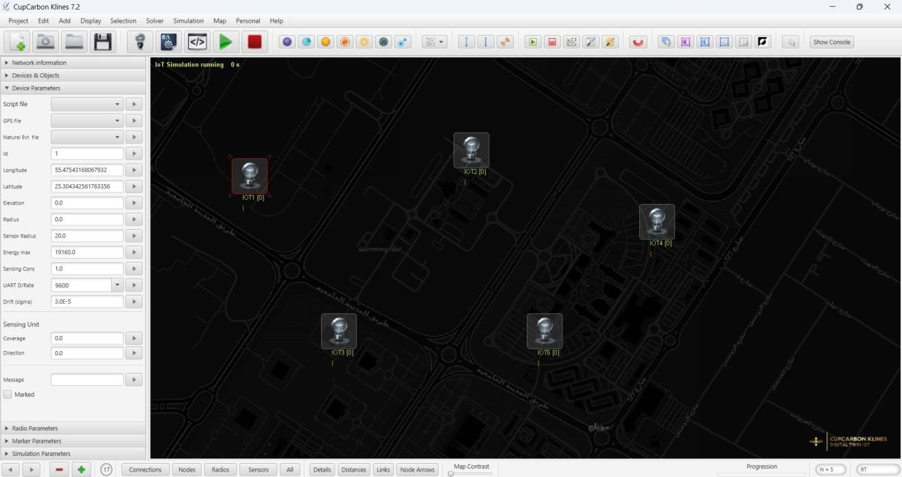

Step 3: Observe the Network Layout
After placing the nodes:

  - The nodes represent wireless sensors in the network.
  - Their positions can be adjusted by dragging them on the map.

Observation
  - CupCarbon allows users to simulate wireless sensor networks on a geographic map.
  - Sensor nodes can be added and positioned at different locations.
  - The software provides tools to configure nodes and simulate network communication.

Conclusion

Conclusion
Successfully studied various types of sensors along with their specifications and applications.

